String in Java 2

Assignment

Question 1- Write a simple String program to take input from user

Ans-

Here’s a simple Java program that takes input from user as a String:

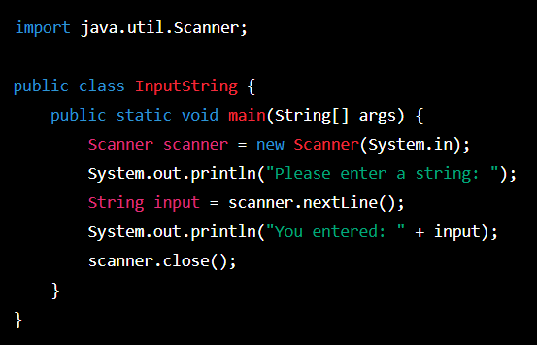

This program prompts the user to enter a String, reads the input using a ‘scanner’ object, and then prints the back to the console.

To run this program, save it as a file named ‘InputSting.java’ and then compile and run it using the following commands in your terminal or command prompt:

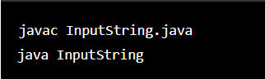

After running the program, you should see the prompt message ‘Please enter a string: ‘in the console. Type a string and press Enter. The program will then print the string you entered. Finally, the ‘scanner’ object is closed to free up system resources.

Question 2- How do you concatenate two strings in Java ? Give an example?

Ans-

We can concatenate two strings using the “+” operator.

Here is an example:

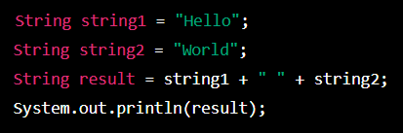

Output:



In the above example, the two strings “Hello” and “world” are concatenated using the “+” operator and the result is stored in a new string variable called “result”. The resulting string is then printed to the console using the ‘System.out.println()’ method. Note that you can concatenate any number of strings using this method by simply adding more “+” operators and string literals.

Question 3- How do you find the length of a string in Java Explain with an example?

Ans-

In Java, we can find the length of a string using the ‘length()’ method of the ‘string’ class.this method returns the number of characters in the string.

Here’s a example:

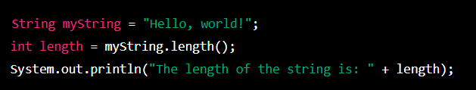

In this example, we first declare a string ‘myString’ with the value “Hello, world!”. We then call the ‘length()’ method on ‘myString’ and assign the result to the integer variable ‘length’. Finally, we print out the length of the string using ‘System.out.println()’.

]

When you run this code, the output will be:



This means that the string “Hello,world!” contains 13 characters, including spaces and punctuation.

Question 4- How do you compare two strings in Java? Give an Example?

Ans-

In Java, you can compare two strings using the ‘equals()’ method or the ‘compareTo()’

Method. Here’s a short example using the ‘equals()’ method:

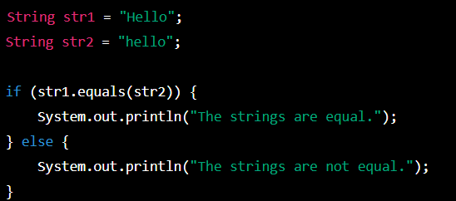

Output: ‘The strings are not equal.’

Note that the ‘equals()’ method is case-sensitive, so ‘str1’ and str2’ are not considered equal because the “H” in ‘str1’ is capitalized, whereas the “h” in ‘str2’ is not.

Question 5- Write a program to find the length of the string “refrigerator”.

Ans-

To find the length of the string “refrigerator” using the ‘length()’ method of the ‘string’ class:

public class StringLength {

public static void main(String[] args) {

String myString = "refrigerator";

int stringLength = myString.length();

System.out.println("The length of the string '" + myString + "' is " + stringLength + ".");

}

}

Output:

The length of the string 'refrigerator' is 12.

In this program, I declare the string’”refrigerator”’ using the ‘string’ class, then we call the ‘length()’ method of the ‘string’ class to find its length, and finally we print out the result using ‘System.out.println()’.

Question 6- Write a program to check if the letter ‘e’ is present in the word ‘umbrella’.

Ans-l

To check if the letter ‘e’ is present in the word ‘umbrella’:

public class CheckLetter {

public static void main(String[] args) {

String word = "umbrella";

if (word.contains("e")) {

System.out.println("The letter 'e' is present in the word 'umbrella'.");

} else {

System.out.println("The letter 'e' is not present in the word 'umbrella'.");

}

}

}

This program first assigns the string ‘umbrella’ to the variable ‘word’. Then it uses the ‘contains () ‘method to check if the string “e” is present in the ‘word’ string. If the condition is true,it prints “The letter ‘e’ is present in the world ‘umbrella’.” Otherwise, it prints “The letter ‘e’ is not present in the world ‘umbrella’.”

Question 7- Write a program to delete all consonants from the string “Hello, have a good day”.

Ans-

To delete all consonants from the given string using regular expressions:

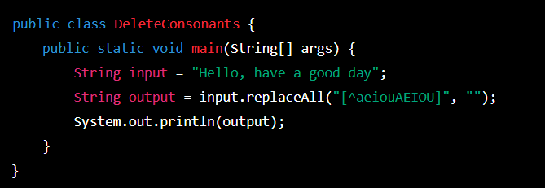

Output: “eoaeaoaa”

Explanation:

. We use the ‘replaceAll()’ method on the input sting, which takes two parameters: the regular expression to search for, and the replacement string.

. The regular expression ‘[^aeiouAEIOU]’ matches all characters that are not vowels (both uppercase and lowercase) in the English alphabet.

. The replacement string is an empty string, so all non-vowel characters (i.e., consonants) and deleted from the input string.

. The resulting string is then printed to the console.